QUESTION 1
A Simple Login System authenticates a user by accepting a username and password and comparing the entered credentials with the expected credentials. The application also provides options for clearing the entered information in the program.
It can be designed using Labels, Textboxes, and Buttons where the user can enter a username and password, and the program checks whether they are correct and below is the form and clear codes for it.

Form Controls

Control | Name | Text/Purpose
Label | lblUsername | Username:
TextBox | txtUsername | Accepts username
Label | lblPassword | Password:
TextBox | txtPassword | Accepts password
Button | btnLogin | Login
Button | btnClear | Clear

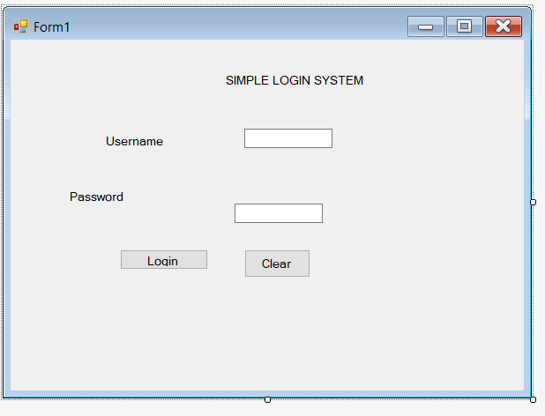
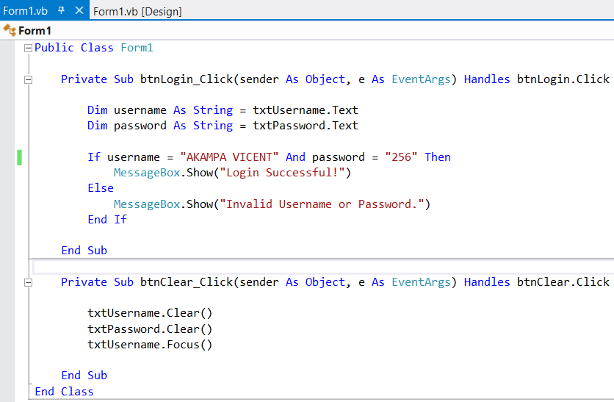
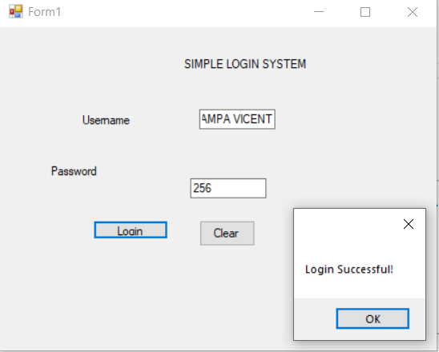

QUESTION 2
The shopping mall program calculates the discount and final amount for three customers. The discount is determined from the purchase amount.
Purchase Amount | Discount
Less than $100 | No discount
$100 to $500 | 10% discount
More than $500 | 20% discount

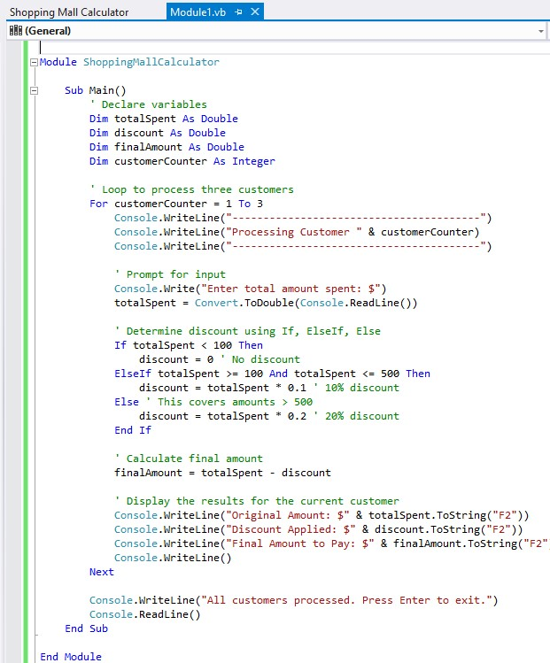

Explanation
The For loop repeats the process three times, once for each customer. The If...ElseIf...Else statement determines the applicable discount. The final amount is obtained by subtracting the discount from the purchase amount.
Examples
- If a customer spends $144, the discount is 14.40 and the final amount is $129.60
- If a customer spends $100, the discount is 10.00 and the final amount is $90.00
- If a customer spends $130, the discount is 13.00 and the final amount is $117.00
Screenshot of the completed Q2 program
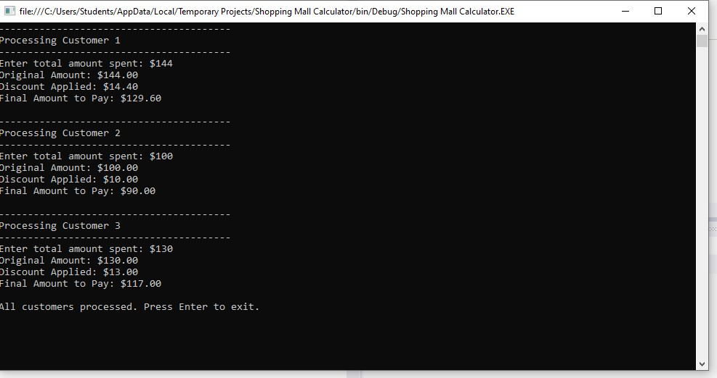

QUESTION 3.
A class is a blueprint or template used to create objects
For example;

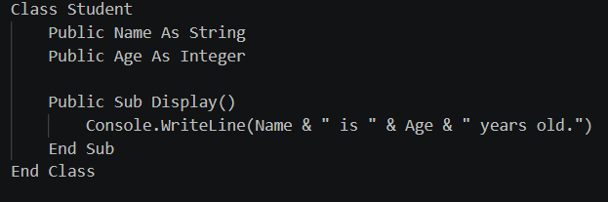

An object is an instance of a class that represents a real entity created from the class.

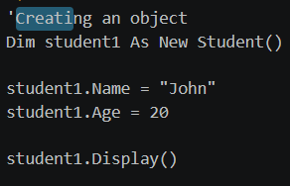

Differentiate between Inheritance and Polymorphism in OOP.

Inheritance | Polymorphism
Allows a child class to acquire members from a parent/base class. | Allows the same operation or method concept to have different implementations.
Promotes code reuse. | Promotes flexibility in object-oriented programs.
Uses inherits in visual basic | polymorphism can be achieved through overriding.
Example: Dog inherits from Animal. | Example: different animals implement MakeSound differently.

For example, for Inheritance

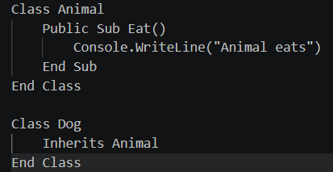

For polymorphism

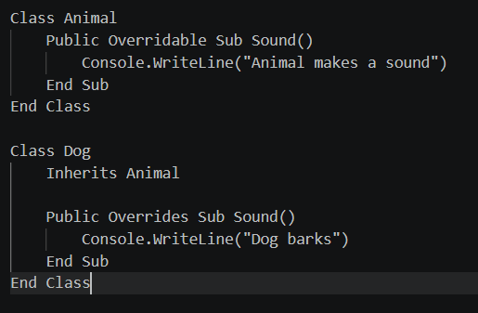

Encapsulation
Encapsulation is the OOP principle of combining data and the methods that operate on that data inside a class while restricting direct access to some of the data.

Importance of encapsulation

- Protects data from unauthorized access.
- Prevents accidental changes to data.
- Makes programs easier to maintain.
- Improves security and organization
- It provides controlled access to data.

A constructor
It is a special method or procedure that runs automatically when an object is created. It is commonly used to initialize the object's data.

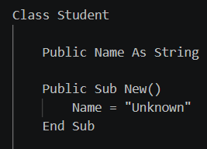

A destructor is used when an object is being removed from memory.

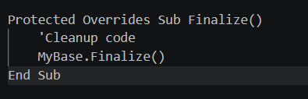

QUESTION 4
Uses of Collections in VB applications
- A collection is used to store and manage multiple values or objects in a single structure.

Collections can store many related items such as names of students.

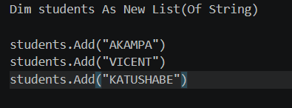

- Easy Searching and Accessing
Collections make it easy to find and access individual items.

- Managing Data Dynamically

Items can easily be added or removed while the program is running.

A Message Box is a small dialog box used to display information, warnings, questions, or errors to the user. And here are examples message box
Information
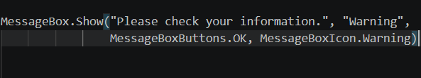
Warning
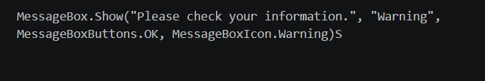
Error
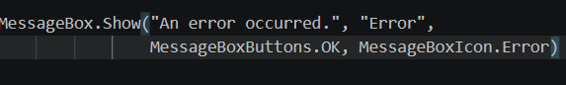
Confirmation:
Asks the user for an OK/Cancel decision.
Question
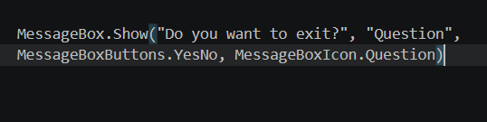

Solution explorer
It is a window in Visual Studio that helps you view and manage the files and components of a project.
It can allow you to:
- View projects and files in a solution.
- Open and edit forms, classes, and code files.
- Add or remove files from a project.
- Rename files and folders.
- View project references and dependencies.
- Access project properties and settings.

QUESTION 5

STUDENT GRADE MANAGEMENT SYSTEM
The Student Grade Management System allows a teacher to enter a student's name and marks for four course units: ICT, Visual Basic, Research Methods, and Cyber & Computer Law. The system validates the input, calculates the total and average, assigns grades, determines pass/fail status and saves the results to a text file.
Part A: Input and Validation
Form controls
Control | Name | Text/Purpose
Label | lblStudentName | Student Name
TextBox | txtStudentName | Student name input
Label | lblICT | ICT
TextBox | txtICT | ICT mark
Label | lblVB | Visual Basic
TextBox | txtVB | Visual Basic mark
Label | lblResearch | Research Methods
TextBox | txtResearch | Research Methods mark
Label | lblCyber | Cyber & Computer Law
TextBox | txtCyber | Cyber & Computer Law mark
Button | btnCalculate | Calculate
Button | btnClear | Clear
Button | btnSave | Save Results
TextBox | txtOutput | Multiline output area

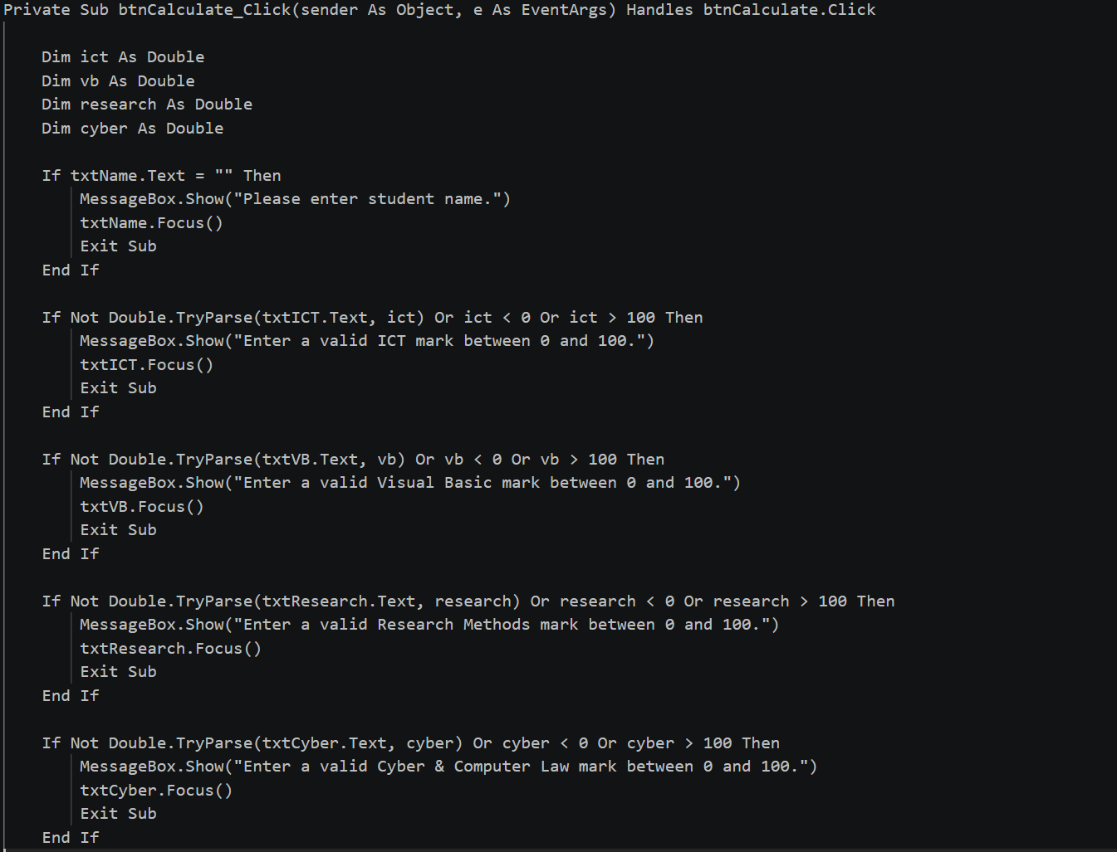

Part B: Calculations and Grading
Marks | Grade
90–100 | A
80–89 | B
70–79 | C
60–69 | D
Below 60 | F

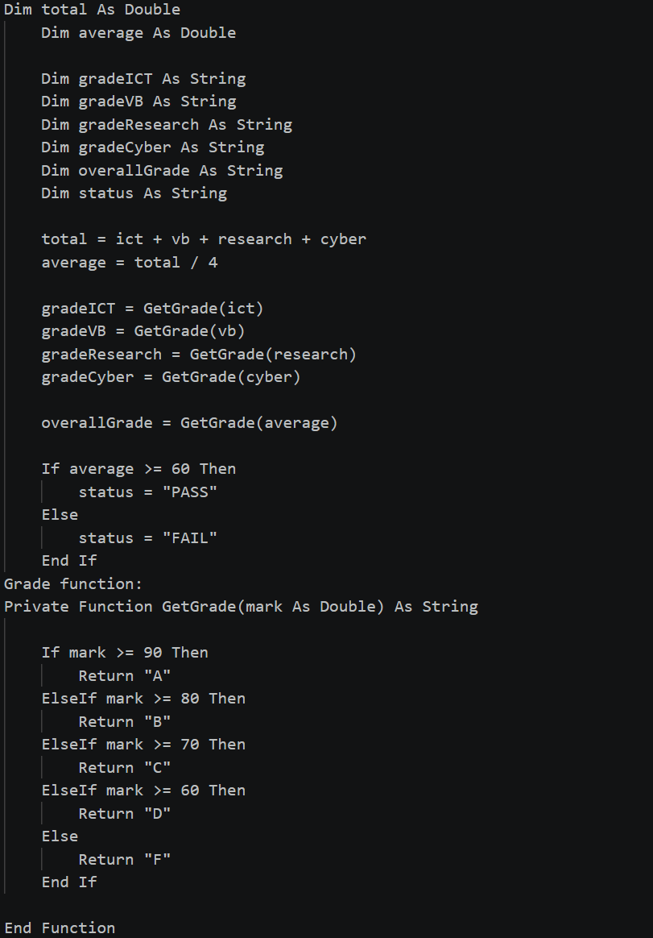

Part C: Output and Reporting
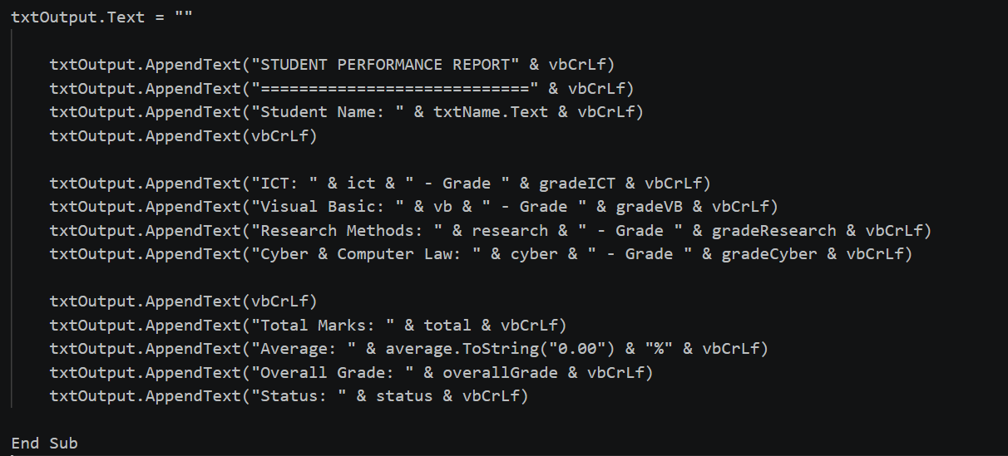

Clear button
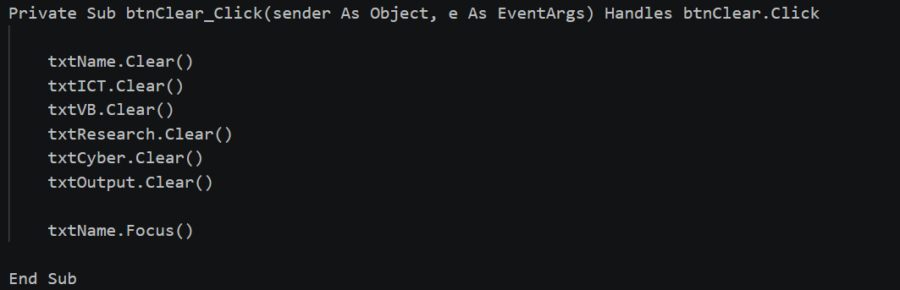

Save Results Button
